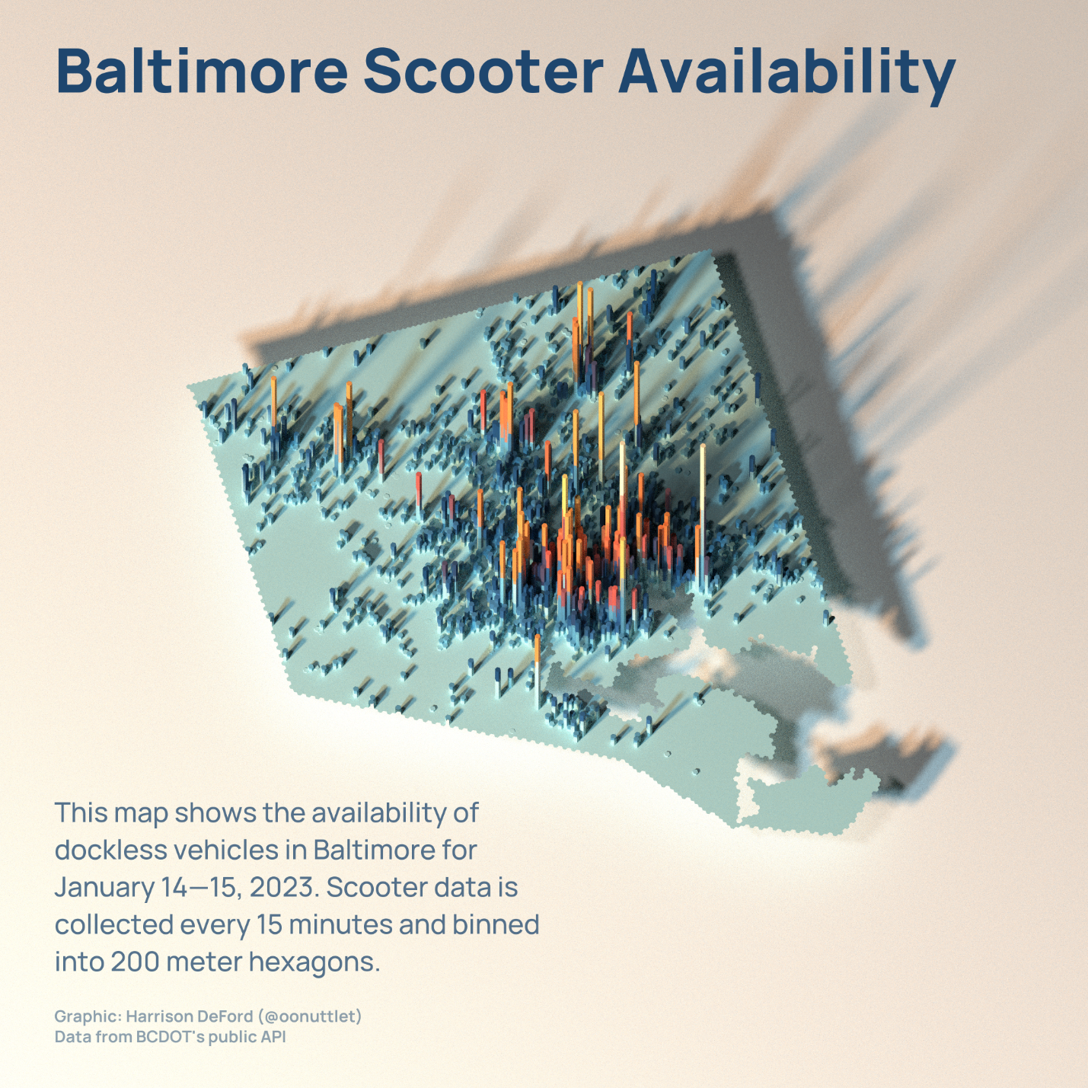

A weekend in micromobility

Mapped above is the availability of scooters in Baltimore for the weekend of January 14th and 15th, 2023. Despite limited commuting, scooters remain most available in the Inner Harbor, with hotspots near JHU, MSU, and Metro stations along the Reisterstown Road corridor. The Harford Road corridor is also visible from scooter availability, with high availability at Harford Rd. and Southern Ave. Since the Ravens were on the road in Cincinnati on January 15, there are fewer scooters available in the M&T/Camden area for this weekend. Vehicles were least available north of Cold Spring and 83, and west of Leakin Park. On average, 2,738 vehicles were available across the city over the weekend.